Grade 7 Accelerated · Unit 3 · Lesson 9  Writing Small Numbers in Scientific Notation  Question Bank - Additional 3.09 ANSWER KEY | Name  Date  Period

Show your work. Circle your final answer.
For questions 1 through 4, write each number in scientific notation.
1. 0.008
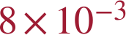

2. 0.00000026


3. 0.0475
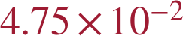

4. 0.000000000091 seconds
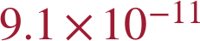 s

For questions 5 and 6, write each number in standard form.
5. 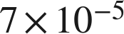
0.00007

6. 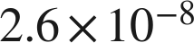
0.000000026

Powers of ten.
7. Write each value as a single power of 10, then as a fraction or decimal.
a. 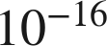, as a fraction

b. 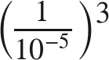
c. 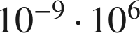


8. Two measurements are 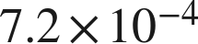 and 0.00000018.
a. Write in standard form.
0.00072
b. Write 0.00000018 in scientific notation.

c. Which of the two is greater? Explain how you know.
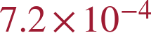 — −4 is greater than −7, so its power of 10 is larger; 0.00072 > 0.00000018.

9. Complete each comparison.
a. How many times larger is 8.4 than 2.1?
4
b. How many times larger is 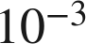 than 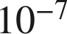?

c. How many times larger is 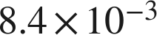 than 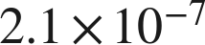?
4 × 10⁴ = 40,000 times larger

10. Write each value in scientific notation.
a. 112 ten-thousandths
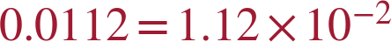
b. 0.00112
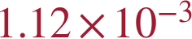
c. 112 billionths

11. Which is 0.00067 written in scientific notation?
○ A. 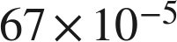
○ B. 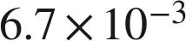
● C. 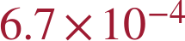
○ D. 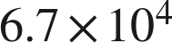
C

12. Select ALL of the expressions that are equal in value to 0.0034.
☒ A. 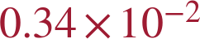
☐ B. 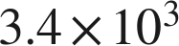
☒ C. 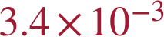
☒ D. 
☐ E. 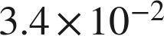
☒ F. 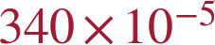
A, C, D and F
Only C is in scientific notation.

13. A grain of pollen has a mass of about 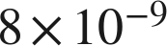 gram. A bag of flour has a mass of about 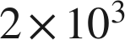 grams.
a. How many times larger is the mass of the bag of flour? Write the answer in scientific notation.
 times
2 ÷ 8 = 0.25 and 3 − (−9) = 12; the product 0.25 times 10¹² is rewritten with a coefficient in [1, 10).
b. How many times smaller is the grain of pollen than the bag of flour?
times smaller — the same comparison read the other way.

